##### A FINANCIAL ANALYSIS REPORT ON PVR LIMITED

##### 20 April 2020



#### BY

#### Aakash Sunkara 2017A4PS0729H

#### Under the supervision of

#### Dr. Thota Nagaraju and Dr. Shreya Biswas

##### SUBMITTED IN PARTIAL FULLFILLMENT OF THE REQUIREMENTS OF





DERIVATIVES AND RISK MANAGEMENT (DRM)

##### BIRLA INSTITUTE OF TECHNOLOGY AND SCIENCE, PILANI HYDERABAD CAMPUS

#### Contents

Section 1 4

1. Underlying equity asset introduction 4
   1. Nature of the business 4
   2. Nature of Ownership 4
   3. History of the company 4
   4. Which industry it belongs? Importance in the industry 4
   5. Overall greatness of the company 5
2. Risk unadjusted data 5
3. Risk adjusted data 5
4. Economic interpretation 7

Section 2 8

1. Equity Futures introduction 8
2. When it is started 8
3. Lot size and contract specifications 8
4. Overall greatness of equity futures investment 9
5. Risk unadjusted data 10
6. Current month 10
7. Next month 10
8. Far month 11
9. Risk adjusted data 11
10. Current month 11
11. Next month 12
12. Far month 12
13. Economic interpretation 13

Section 3 14

1. Comparison of risk unadjusted and risk adjusted 14

Section 4 16

1. Contango or backwardation 16
2. Frequency 17

Section 5: Options 17

Section 6 18

1. Conclusion 18

Section 7 19

1. References 19

# Section 1

1. **Underlying equity asset introduction**
2. **Nature of the business**

PVR Cinemas is a one of the largest firms operating in entertainment sector in India. PVR stands for Priya Village Roadshow. This company currently has the largest multiplex chains in India.

1. **Nature of Ownership**

PVR is a privately owned firm. As of April 20 2020, foreign institutions hold 38.35% of the shares followed by banks mutual funds with a stake of 20%. Promoters hold 18.54% whereas financial institutions have 14.68% of stocks. General public holds only 4.51% and government doesn’t have any shares.

1. **History of the company**

Origin of this company can be traced back to the year 1978 where it was born as Priya cinema by Ajay Bijili. Later, it was expanded by the collaboration of Village Roadshow Limited and Priya Exhibitors Private Limited in 1995 with a 40:60 ratio. The company commenced its operations in June 1997.

### Which industry it belongs? Importance in the industry

Considering the market share of firm in the entertainment industry, PVR can be easily called as the game changer. In 2012, Cine Hospitality Private Limited, a subsidiary of PVR purchased CineMAX, which made PVR the largest cinema chain in India. In 2016, PVR acquired DT cinemas and cinemas business of DLF. In 2018, it has acquired SPI cinemas. Since then it has been acquiring many firms in the industry and continuing to grow both in terms of market capital and profit.

1. **Overall greatness of the company**

PVR has reached a milestone of 100 screens early in 2008 and now it currently owns over 800 screens. PVR is the first firm to launch an IMAX screen in India. PVR also launched North India’s largest called PVR superplex in 2015. It has 15 screens under a single roof. In 2019, it has launched PVR LUXE which it believes would be the game changer in luxury cinema.

1. **Risk unadjusted data**

|  |  |  |  |
| --- | --- | --- | --- |
| *Metric/Frequency* | *Daily* | *Weekly* | *Monthly* |
| *Mean (%)* | 0.1404 | 0.6726 | 2.6782 |
| *Max (%)* | 7.6356 | 13.6071 | 24.1406 |
| *Min (%)* | -13.0976 | -11.4466 | -19.3725 |
| *Standard deviation* | 2.1149 | 4.5867 | 12.4198 |

1. **Risk adjusted data**

|  |  |  |  |
| --- | --- | --- | --- |
| *Metric/Frequency* | *Daily* | *Weekly* | *Monthly* |
| *Mean (%)* | 0.1223 | 0.5458 | 2.1287 |
| *Max (%)* | 7.6167 | 13.4735 | 23.5647 |
| *Min (%)* | -13.1155 | -11.5735 | -19.9297 |
| *Standard deviation* | 2.1149 | 4.5868 | 12.4137 |

|  |  |  |  |
| --- | --- | --- | --- |
| *Sharpe ratio* | 0.05782 | 0.11898 | 0.17148 |

*Table 1 Numbers marked in red indicate the optimal values of the quantities*

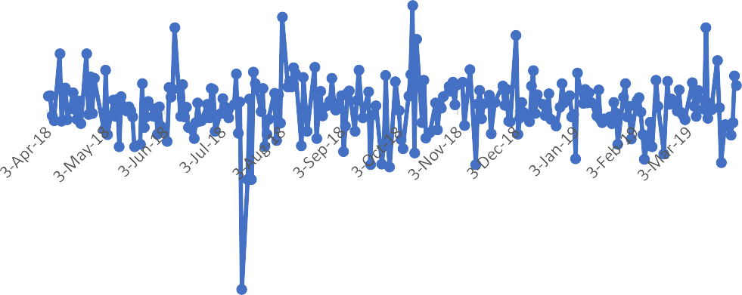

Risk Adjusted Returns of PVR on Daily Basis

10.0000

5.0000

-

-5.0000

-10.0000

-15.0000

Date

*Figure 1 This figure indicates risk adjusted returns of PVR on Daily basis*

*Figure 1. This figure indicates risk adjusted returns of PVR on Daily basis*

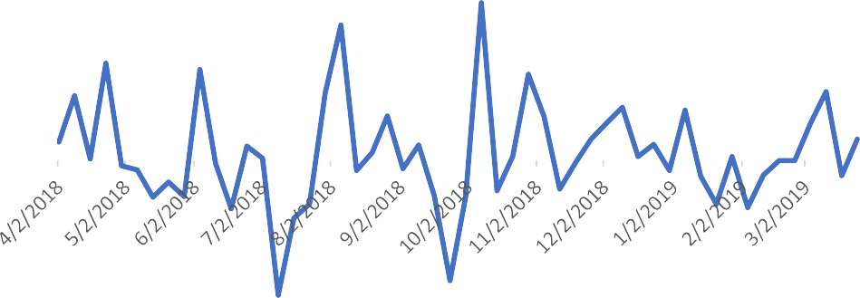

Risk Adjusted Returns of PVR on Weekly Basis

15.0000

10.0000

5.0000

-

-5.0000

-10.0000

-15.0000

Date

Returns (%)

*Figure 2 This figure indicates risk adjusted returns of PVR on Weekly basis*

Returns (%)

Returns (%)

*Figure 3 This figure indicates risk adjusted returns of PVR on Monthly basis*



Risk Adjusted Returns of PVR on Monthly Basis

30

25

20

15

10

5

0

-5

-10

-15

-20

-25

Date

1. **Economic interpretation**

From the above given tables, the better measure to choose whether to invest or not is risk adjusted returns. This is because it gives us the net return we would earn when compared to risk-free government bonds (T-bills). As it is evident from the above tables that all the daily, weekly and monthly risk adjusted mean returns are positive, it can be concluded that the equity instrument definitely performed better than a risk-free sovereign bond. Hence, a hedger or risk averse investor can consider investing in the equity of PVR. Sharpe ratio is defined as the difference between return earned by equity and risk-free sovereign bond divided by the excess return of the stock. As the Sharpe ratio for monthly is highest, the return obtained on unit excess risk is highest for monthly equity. Hence this would be best strategy among equity for hedgers. For speculators who look for highest returns regardless of the risk, considering the option which gives highest return would be beneficial, which is also monthly equity option in this case.

# Section 2

1. **Equity Futures introduction**
2. **When it is started**

Futures in India are dependent on National Stock Exchange of India Limited (NSE). NSE started trading on derivatives from the year 2000. PVR Limited was listed in the stock market in the year 1995. Futures on individual securities were started on November 9, 2001.

1. **Lot size and contract specifications**

|  |  |
| --- | --- |
| *Symbol* | PVR |
| *Instrument* | FUTSTK |
| *Lot Size* | 400 shares |
| *Trading cycle* | 3 months – Current, Next & Far |
| *Trading hours* | As in equity derivative segment |
| *Expiry date* | Last Thursday of expiry month |
| *Daily settlement price* | Last half hour’s weighted average price |
| *Final settlement price* | Closing price of underlying equity on the last trading day of the contract |

### Overall greatness of equity futures investment

Current details of futures instrument (Expiry on April 30, 2020)

|  |  |
| --- | --- |
| **Open Price** | 1,151.35 |
| **High Price** | 1,151.90 |
| **Low Price** | 1,082.00 |
| **Prev. Close** | 1,168.55 |
| **Spot Price** | 1,136.00 |
| **Open Int PCR** | 1.10 |
| **Prev OI PCR** | 1.19 |
| **Bid Price** | 1,086.45 |
| **Bid Qty** | 400 |
| **Rollover %** | 15.11% |
| **Average Price** | 1,110.86 |
| **No. of Contracts Traded** | 2,165 |
| **Turnover (Rs. in lakhs)** | 9,620.05 |
| **Market Lot** | 400 |
| **Open Interest** | 1,281,200 |
| **Open Int. Chg** | 28,000 |
| **Open Int. Chg %** | 2.23 |
| **Offer Price** | 1,087.80 |
| **Offer Qty** | 400 |
| **Rollover Cost** | -88.00 |
| **(Source: www.moneycontrol.com)** |  |

It can be seen that the current PCR is above 1, meaning the customer sentiment is bearish. This is caused due to the national wide lockdown due to the novel Corona virus pandemic. This lockdown caused all the PVR and other multiplexes to be closed. Hence business was halted and customers developed a bearish sentiment. But compared to the previous month PCR ratio, this month’s value has decreased, indicating that although most people are having bearish sentiment, the number of people having pessimistic opinion are decreasing. This indicates the growth potential of cash inflows or investments from investors and hence company.

1. **Risk unadjusted data**
2. **Current month**

|  |  |  |  |
| --- | --- | --- | --- |
| *Metric/Frequency* | *Daily* | *Weekly* | *Monthly* |
| *Mean (%)* | 0.1356 | 0.6412 | 1.8595 |
| *Max (%)* | 7.5050 | 13.6774 | 22.9645 |
| *Min (%)* | -12.9657 | -11.7818 | -18.6343 |
| *Standard deviation* | 2.0833 | 4.6822 | 11.9846 |

1. **Next month**

|  |  |  |  |
| --- | --- | --- | --- |
| *Metric/Frequency* | *Daily* | *Weekly* | *Monthly* |
| *Mean (%)* | 0.1355 | 0.6372 | 1.8526 |
| *Max (%)* | 7.1654 | 13.5593 | 22.9322 |
| *Min (%)* | -13.3884 | -11.9425 | -18.8560 |
| *Standard deviation* | 2.0971 | 4.6911 | 12.0345 |

1. **Far month**

|  |  |  |  |
| --- | --- | --- | --- |
| *Metric/Frequency* | *Daily* | *Weekly* | *Monthly* |
| *Mean (%)* | 0.1368 | 0.6433 | 1.8957 |
| *Max (%)* | 7.3552 | 13.1337 | 23.1166 |
| *Min (%)* | -13.2614 | -11.8183 | -18.8603 |
| *Standard deviation* | 2.0920 | 4.6421 | 12.1055 |

1. **Risk adjusted data**
2. **Current month**

|  |  |  |  |
| --- | --- | --- | --- |
| *Metric/Frequency* | *Daily* | *Weekly* | *Monthly* |
| *Mean (%)* | 0.1175 | 0.5142 | 1.3057 |
| *Max (%)* | 7.4860 | 13.5449 | 22.3886 |
| *Min (%)* | -12.9836 | -11.9075 | -19.1915 |
| *Standard deviation* | 2.0833 | 4.6822 | 11.9770 |
| *Sharpe ratio* | 0.0564 | 0.1098 | 0.1090 |

1. **Next month**

|  |  |  |  |
| --- | --- | --- | --- |
| *Metric/Frequency* | *Daily* | *Weekly* | *Monthly* |
| *Mean (%)* | 0.1174 | 0.5103 | 1.2988 |
| *Max (%)* | 7.1468 | 13.4268 | 22.3562 |
| *Min (%)* | -13.4063 | -12.0682 | -19.4131 |
| *Standard deviation* | 2.0970 | 4.6911 | 12.0270 |
| *Sharpe ratio* | 0.0559 | 0.1087 | 0.1079 |

1. **Far month**

|  |  |  |  |
| --- | --- | --- | --- |
| *Metric/Frequency* | *Daily* | *Weekly* | *Monthly* |
| *Mean (%)* | 0.1187 | 0.5163 | 1.3419 |
| *Max (%)* | 7.3363 | 13.0012 | 22.5406 |
| *Min (%)* | -13.2793 | -11.9440 | -19.4175 |
| *Standard deviation* | 2.0919 | 4.6421 | 12.0983 |
| *Sharpe ratio* | 0.0567 | 0.1112 | 0.1109 |

1. **Economic interpretation**

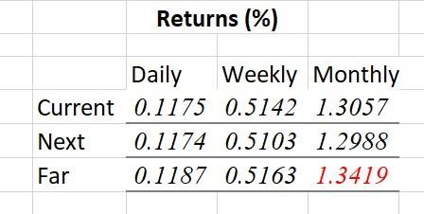

*Figure 4 Risk adjusted returns of all months at all time periods. Highlighted is the optimal return*

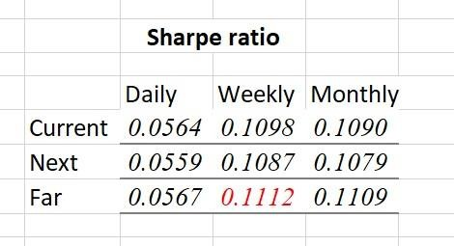

*Figure 5 Sharpe ratios of all months of all time periods. Highlighted is the optimal Sharpe ratio*

As it was already constructed, risk adjusted returns are better means to compare between instruments. In the case of equity backed futures, all the daily, weekly and monthly mean returns of current, near and far months are positive. This indicates that any future instrument of PVR has performed better than a risk-free government bond in any particular period. Hence, it can be safely stated that PVR futures is an adept option to invest. Looking at the returns obtained within the tables, it can be unambiguously said that the monthly returns are the highest. In the figures given above, numbers painted in red are most optimal for PVR futures. In terms of mean returns obtained, far month has performed the best. Therefore, a speculator should invest in monthly far month futures of PVR as this yields the highest returns amongst all. Coming to the scenario of hedger, a hedger invests in the instrument having highest Sharpe ratio. Observing all the Sharpe ratios, we

can deduce that the value is highest for weekly far month. Hence a hedger or risk averse investor must invest in weekly far month futures instrument of PVR.

Returns (%)

# Section 3

## Comparison of risk unadjusted and risk adjusted

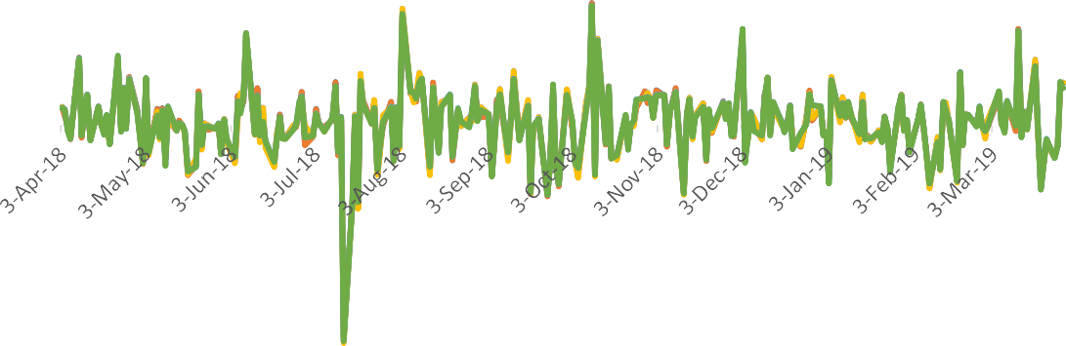

Risk adjusted returns Current Month (%)

Risk adjusted returns Next Month (%) Risk adjusted returns Far Month (%)

Returns Current Month (%)

Returns Next Month (%) Returns Far Month (%)

Date

-15

-10

-5

0

5

10

Returns of Futures Daily

*Figure 6 Daily returns on Futures in all the months (Current, Near, Far)*

Returns (%)

Returns (%)

*Figure 7 Weekly returns on Futures in all the months (Current, Near, Far)*

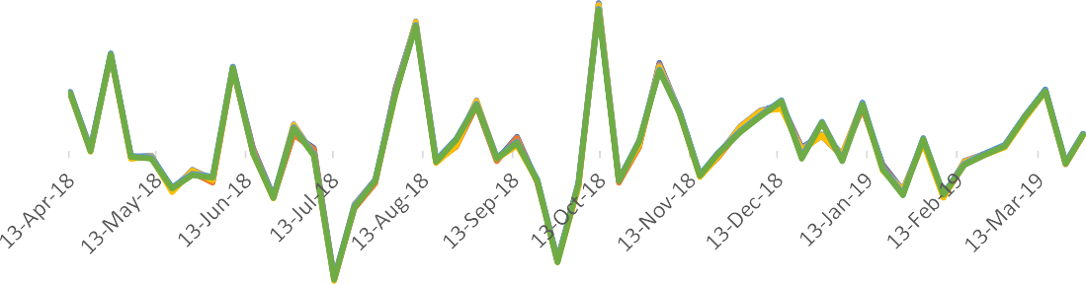

Returns Next Month(%) Risk adjusted returns Next Month (%)

Returns Far Month (%) Risk adjusted returns Far Month (%)

Risk adjusted returns Current Month (%)

Returns Current Month(%)

Date

15

10

5

0

-5

-10

-15

Returns of Futures Weekly

*Figure 8 Monthly returns on Futures in all the months (Current, Near, Far)*



Returns of Futures Monthly

30

25

20

15

10

5

0

-5

-10

-15

-20

-25

Date

Returns Far month (%)

Risk adjusted returns Far month (%)

Returns Next month (%) Risk adjusted returns Next month (%)

Returns Current month (%) Risk adjusted returns Current month (%)

As we have seen above, risk adjusted return is the return obtained in excess to that of risk-free government bond. Hence, comparatively the risk unadjusted returns will be higher. This can be seen from charts above. Regarding the liquidity of the futures, on an average, the open interest for current month remains the

highest and is in the order of 10^6 - 10^7 shares. The range was decreased to 10^4

**FO-SO**

**(IN INR)**

* 10^5 for the next month during this one-year period. Far month has the least open interest which almost remains zero at all times and barely reaches 500 shares. Hence, the most liquid future id the current month’s future followed by next month’s future and the liquidity is practically zero for far month in futures segment of PVR.

# Section 4

1. **Contango or backwardation**

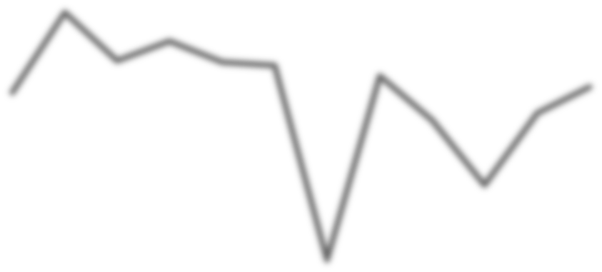

**Equity vs Futures**

40

20

0

-20

-40

-60

-80

**DATE**

Fo-So

*Figure 9 The above figure shows the net of equity price and futures price*

As seen from the chart, the futures prices were higher from April 2018 to September 2018. Hence, the futures exhibited contango during that period. Later on, in October it was contango again. But after that the behaviour was backwardation till February 2019. In the last month of the analysis period i.e. March 2019 the contango behaviour surfaced.

1. **Frequency**

As per theory, assuming efficient market hypothesis, the prices of stocks and hence should not depend on frequency of trading. This can be attributed to Random Walk Behaviour of the stock prices. But in real life scenario, the market is not efficient and hence depends on the frequency as concluded in the above interpretations.

# Section 5: Options

|  |  |
| --- | --- |
| **Duration** | October 2018 – December 2018 |
| **Strike Price** | 1300 Rs |
| **Standard Deviation** | 0.0204 |
| **Annualized volatility** | 0.3240 |
| **u** | 1.1759 |
| **d** | 0.8504 |

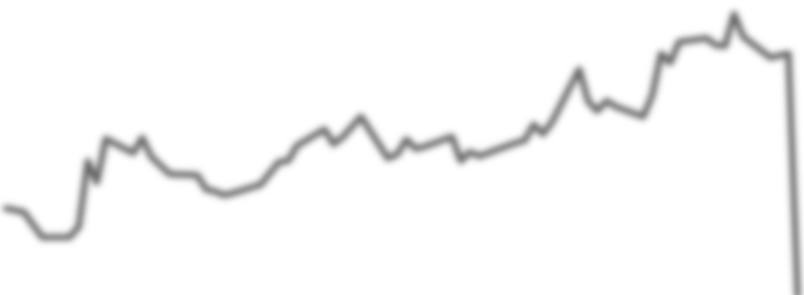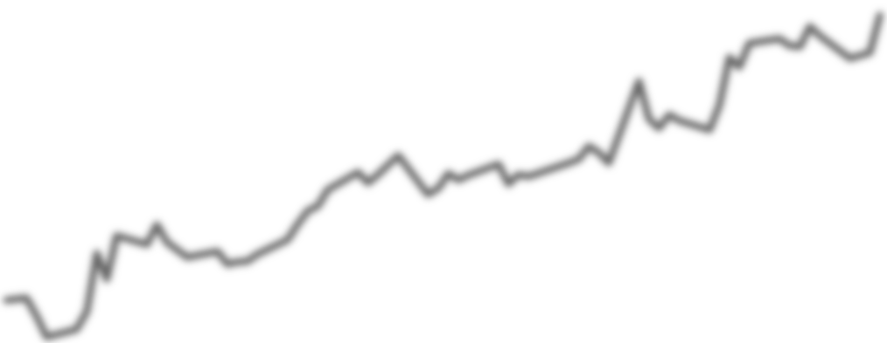

Theoretical option price

Settle Price

350

300

250

200

150

100

50

0

**Options**

*Figure 10 Plot showing calculated premium vs actual premium*

The theoretical option premium is calculated using binomial tree method. It can be noted from the above figure that initially, the difference between the theoretical and actual price is high but as the time goes, they both converge and the difference almost goes to zero.

# Section 6

1. **Conclusion**

In the overall discussion above, it can be concluded that any instrument of PVR yielded a return greater than a risk-free government bond. Among futures and equity, the highest return of equity was for monthly which was 2.1287% whereas for futures was 1.3419%. Clearly, equity yielded more than any other futures instrument. Hence, the optimal instrument for a speculator to invest is in monthly equity based on the historical analysis. Regarding the Sharpe ratio, the highest among equity instruments was 0.1715 whereas for futures is 0.1112. Hence, the best strategy for a risk-averse investor would be to invest in monthly equity.

# Section 7

1. **References**
   * Wikipedia.com
   * PVR website
   * Moneycontrol.com
   * NSE India (both old and new websites)
   * Economictimes.com